**Public Transit Ridership and Funding Analysis: A Comparative Study**

Vaishnavi Mada

J. Mack Robinson College of Business

MGT 8020: Business Intelligence

Dr. Frank Lee

June 24, 2024

#### **Introduction**

#### Public transportation is a cornerstone of urban mobility, providing essential services to millions of residents and contributing to the economic and environmental sustainability of cities. This study aims to analyze the trends in public transit ridership and funding across different cities in the United States, with a specific focus on the impact of recent years, including the COVID-19 pandemic. By examining ridership patterns, funding sources, and revenue distribution, we can gain insights into the strengths and challenges facing public transit systems.

#### **Research Questions**

1. What are the trends in total public transit ridership over the past few years?
   * Understanding these trends helps assess the impact of external factors, such as the COVID-19 pandemic, on public transit usage.
2. How has the funding for public transit evolved, and what are the major sources of this funding?
   * Analyzing funding sources provides insights into the financial sustainability and dependencies of public transit systems.
3. What is the revenue distribution among different transit agencies, and how do they compare?
   * Comparing revenue distribution across agencies highlights the financial disparities and helps identify areas needing attention.

#### **Personal Motivation**

As someone hailing from a country where public transport is a vital aspect of daily life, the stark contrast in the availability and efficiency of public transportation in the United States has been a significant challenge. Commuting difficulties have underscored the importance of robust public transit systems. This personal experience has driven me to visualize and analyze the state of public transportation in the U.S., aiming to understand its dynamics and advocate for improvements.

#### **Data Preparation**

The dataset includes quarterly and annual ridership data, as well as detailed funding and revenue information for various transit agencies is from the American Public Transportation Association <https://www.apta.com/research-technical-resources/transit-statistics/> . The data was organized in Excel and imported into Tableau for visualization.

### **Findings and Visualizations**

#### **Visualization 1:**

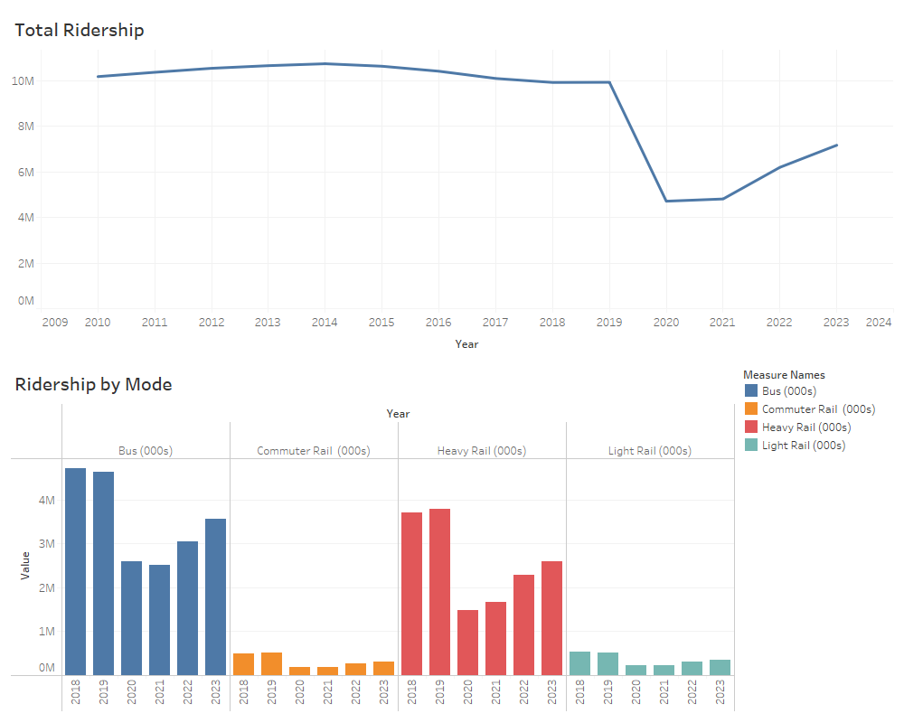

#### Top Chart: Total Ridership

* Time Span: From 2009 to 2024.
* Trend: The total ridership shows a steady increase until around 2019. There is a sharp decline starting in 2020, which correlates with the onset of the COVID-19 pandemic.
* Recovery: There is a gradual recovery observed starting from 2022, but the ridership levels in 2023 have not yet returned to the peak levels observed in 2018-2019.

#### Bottom Chart: Ridership by Mode

* Modes Included: Bus, Commuter Rail, Heavy Rail, and Light Rail.
* Bus Ridership: Shows a significant drop from 2019 to 2020, followed by a gradual recovery, but still lower than pre-pandemic levels.
* Commuter Rail: Consistently lower ridership compared to buses and heavy rail, with a noticeable decline in 2020 and slight recovery by 2023.
* Heavy Rail: Exhibits a similar trend to bus ridership with a sharp decline in 2020 and partial recovery by 2023.

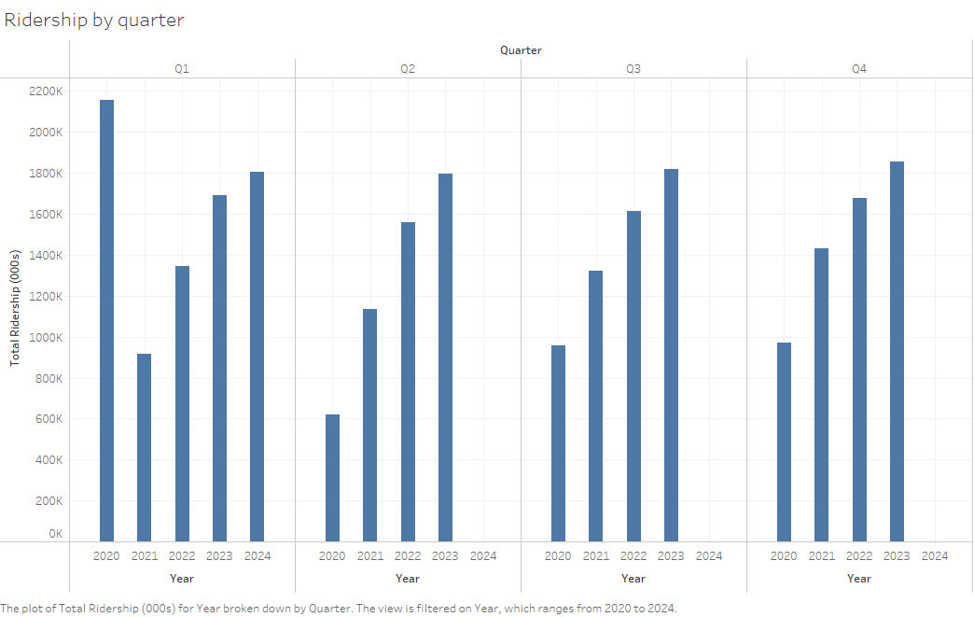

This bar chart illustrates the total ridership across different quarters from 2020 to 2024. The significant drop in 2020 and 2021 highlights the impact of the COVID-19 pandemic on public transit usage. The gradual recovery in 2022 and 2023 indicates a return to pre-pandemic levels, though not fully achieved by 2024.

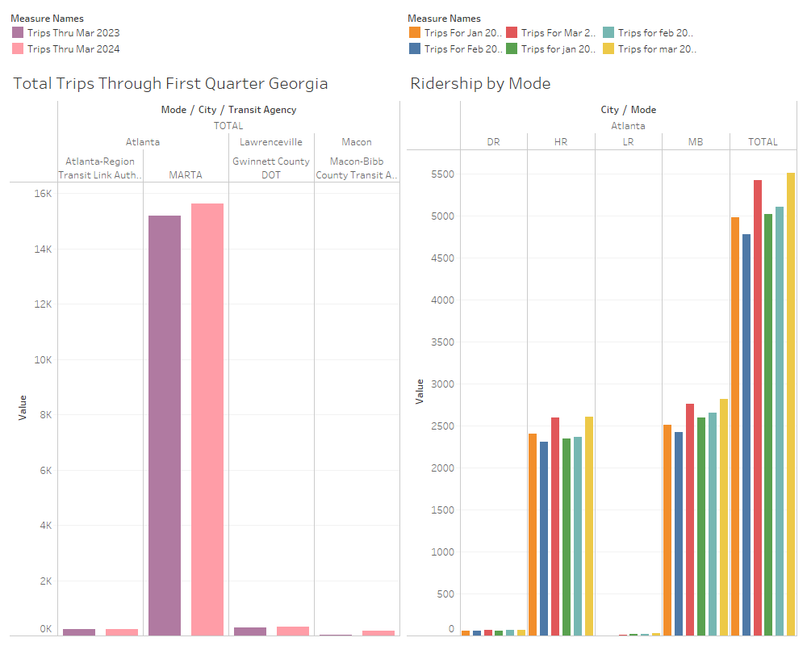

The image presents two visualizations focusing on public transportation ridership in Georgia.

### Left Chart: Total Trips Through First Quarter Georgia

Comparison: This chart compares the total number of trips for the first quarter of 2023 and 2024 across different transit agencies in Georgia.

* Agencies:
  + Atlanta-Region Transit Link Authority
  + MARTA (Metropolitan Atlanta Rapid Transit Authority)
  + Gwinnett County DOT
  + Macon-Bibb County Transit Authority
* Observation:
  + MARTA has the highest number of trips in both 2023 and 2024.
  + There is a noticeable increase in trips for 2024 compared to 2023 for both Atlanta-Region Transit Link Authority and MARTA, indicating a recovery trend.
  + Smaller agencies like Gwinnett County DOT and Macon-Bibb County Transit Authority have significantly lower trip numbers, but also show a slight increase.

### Right Chart: Ridership by Mode

* Modes Included:
  + DR (Demand Response)
  + HR (Heavy Rail)
  + LR (Light Rail)
  + MB (Bus)
* Comparison: The chart compares ridership across different modes for January, February, and March of 2023 and 2024.
* Observation:
  + Bus (MB) mode consistently has the highest ridership among all modes.
  + Heavy Rail (HR) is the second highest, followed by Light Rail (LR) and Demand Response (DR).
  + Ridership increases steadily from January to March for each year.
  + 2024 shows higher ridership compared to 2023 for most modes, reflecting a positive growth trend.

### **Insights:**

Recovery Trends: Both charts indicate a recovery in public transit ridership in Georgia from 2023 t0 2024. This recovery is more pronounced in larger transit agencies like MARTA.

Mode-Specific Ridership: Bus and Heavy Rail are the most utilized modes of public transport in Georgia, with consistent growth observed from January to March each year.

Impact of Pandemic: The increase in ridership from 2023 to 2024 suggests a rebound from the pandemic's impact, with more people returning to using public transportation.

Agency Performance: Larger agencies like MARTA show a more significant increase in ridership, highlighting their crucial role in Georgia’s public transportation network.

Quarterly Change Analysis:

Atlanta MARTA

Quarterly Change: 3.01%

Insight: Overall, MARTA has experienced growth in total ridership, underscoring successful strategies in attracting more passengers across different modes.

#### Lawrenceville, Gwinnett Count DOT

#### Quarterly Change: 11%

Insight: Overall growth in ridership, signifying a positive trend and successful service delivery.

#### **Visualization 2: Sustaining Public Transit Through Funding**

#### 

Description: This line chart shows the total funding for public transportation and passenger fare revenue from 1992 to 2022. The top chart demonstrates a steady increase in total funding over the years, with a slight dip post-2020. The bottom chart reveals that passenger fare revenue peaked around 2018 but significantly declined during the pandemic. Reported in the year 2021 the total transit funding was decreased y 5.6 percent. Due to Pandemic, the ridership dropped, and the revenue collection has dropped resulting in 33 percent decline in the passenger fare revenue to 6.4 billion dollars in the year 2021.

Insights:

* Funding Trends: While overall funding has generally increased, passenger fare revenue suffered a substantial hit due to the pandemic.

#### **Visualization 3: Revenue and Funding Streams**

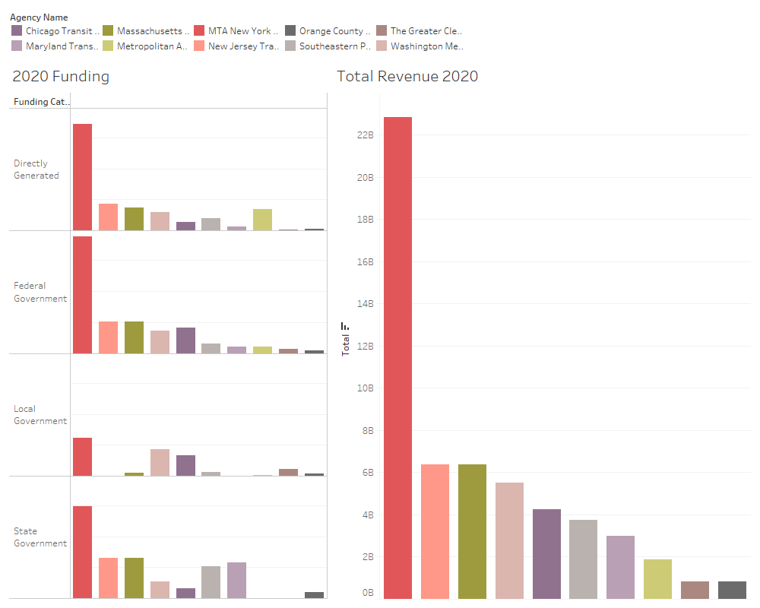

#### **Funding Sources**

Directly Generated Funding:

Highest Contributor: MTA New York City Transit

Observation: MTA New York has the highest directly generated funding, significantly outpacing other agencies.

Other Agencies: Chicago Transit Authority, Massachusetts Bay Transportation Authority, and others contribute smaller amounts, indicating a wide disparity in self-generated revenue across agencies.

Federal Government Funding

Highest Contributor: MTA New York City Transit

Observation: MTA New York also leads in federal government funding, reflecting substantial federal support.

Other Agencies: Similar to directly generated funds, other agencies like New Jersey Transit Corporation and Washington Metropolitan Area Transit Authority receive lower but still significant federal funds.

Local Government Funding

Highest Contributor: MTA New York City Transit

Observation: MTA New York leads again, showcasing strong local government support.

Other Agencies: Agencies such as Washington Metropolitan Area Transit Authority and Southeastern Pennsylvania Transportation Authority receive varying levels of local government funding, highlighting regional differences in support.

State Government Funding

Highest Contributor: MTA New York City Transit

Observation: MTA New York secures the most state government funding, underlining robust state-level backing.

Other Agencies: Agencies like Maryland Transit Administration and Massachusetts Bay Transportation Authority also receive state funding but to a lesser extent.

#### **Total Revenue (2020)**

Highest Revenue: MTA New York City Transit

Observation: MTA New York stands out with the highest total revenue for 2020, indicating its significant scale and financial capability.

Other Agencies: New Jersey Transit Corporation, Massachusetts Bay Transportation Authority, and Washington Metropolitan Area Transit Authority follow but with much lower total revenues compared to MTA New York.

### **Key Takeaways**

Dominance of MTA New York: Across all funding categories, MTA New York City Transit is the leading agency, reflecting its large scale of operations and the substantial financial support it receives from various sources.

Funding Diversity: The image highlights the diverse funding sources for public transit, including directly generated funds, and contributions from federal, local, and state governments.

Disparity in Funding: There is a significant disparity in funding and revenue among different transit agencies, with MTA New York receiving the bulk of the funds compared to other agencies.

### **Conclusion**

The analysis of public transit ridership and funding provides a comprehensive view of the dynamics and challenges faced by public transportation systems in the United States. The COVID-19 pandemic had a profound impact on ridership, with a sharp decline observed across all modes of transportation starting in 2020. This decline underscores the vulnerability of public transit systems to external shocks. However, the data also shows a gradual recovery beginning in 2022, though ridership levels have not yet returned to the peaks observed in 2018-2019.

Different modes of transportation experienced varying levels of impact and recovery. Bus and heavy rail, which account for the majority of ridership, saw significant declines in 2020 followed by a slow rebound. Commuter rail and light rail, which had lower ridership figures, also faced declines but demonstrated signs of recovery by 2023. This mode-specific analysis highlights the importance of tailored strategies to support different types of transit services.

Funding trends reveal a steady increase in total funding for public transportation over the years, with a slight dip post-2020. Passenger fare revenue, however, experienced a substantial decline during the pandemic, dropping by 33 percent to $6.4 billion in 2021. This decline in fare revenue reflects the reduced ridership and the temporary suspension of fare collection by many transit systems to mitigate the spread of the virus.

The financial analysis indicates that MTA New York City Transit is the leading agency in terms of revenue and funding, receiving substantial support from directly generated funds, federal, local, and state governments. This dominance highlights the significant scale and financial capability of MTA New York compared to other transit agencies. The disparity in funding among different agencies underscores the varying levels of financial support and the need for more equitable distribution of resources.

Regional data from Georgia illustrates a recovery trend in public transit ridership from 2023 to 2024, with significant increases observed in larger transit agencies like MARTA. This recovery is indicative of the resilience of public transportation systems and the crucial role they play in urban mobility. The increase in ridership across different modes, particularly buses and heavy rail, reflects a growth trend and a gradual return to normalcy post-pandemic.

In conclusion, the analysis provides a narrative of resilience, recovery, and the ongoing challenges faced by public transportation systems. The findings emphasize the need for continued investment and support to ensure the sustainability and growth of public transit, particularly in the wake of disruptions like the COVID-19 pandemic. Robust public transportation is essential for urban mobility, economic stability, and environmental sustainability, and efforts must be made to strengthen and adapt these systems to future challenges.

**References:**

American Public Transportation Association: Public Transportation Ridership Report.

<https://www.apta.com/research-technical-resources/transit-statistics/>

Public Transportation Fact Book

<https://www.apta.com/research-technical-resources/transit-statistics/public-transportation-fact-book/>

National Transit Database Tables

<https://www.apta.com/research-technical-resources/transit-statistics/ntd-data-tables/>